
A 10
Sreenidhi Institute of Science & Technology
(An Autonomous Institution)
Code No: 101MA04

B. TECH. I – Year II – Semester Examinations, July, 2013 (Supplementary)
ENGINEERING MATHEMATICS - II FOR BIO-TECHNOLOGY (BT)

Time: 3 Hours Max. Marks : 70

Note : No additional answer sheets will be provided.

Part-A (Objective Type)
Max.Marks:20

Answer all QUESTIONS.

1. The order and degree of the differential equation 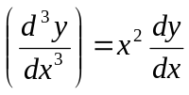are ____, ____.

2. The differential equation satisfied by Y=C₁e^{-x}+C₂e^{x} is __________.

3. The general solution of 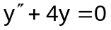 is____________.

4. The Laplace transform of L(e^{at} cos at) is ___________.

5. z=ax+by+ab is a solution of the partial differential equation ______.

6. The set of multipliers to solve the equation x(y-z)p+y(z-x)q=z(x-y) are _____.

7. y(x)=C₁cosx+C₂sinx is a solution of the ordinary differential equation is _____.

8. The inverse Laplace transform of 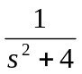 is ________.
9. If f(t+T)=f(t), where T is a constant, then f is a ________ function.

10. If f can be expanded as a half range fourier series (0,π), then b_{n}=_______.

Part – B
Max. Marks: 50

ANSWER ANY FIVE QUESTIONS. EACH QUESTION CARRIES 10 MARKS.

1. a) Solve 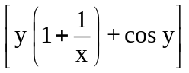dx+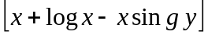dy=0. [ 5 ]
b) Solve 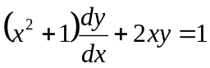. [ 5 ]

2. a) Solve 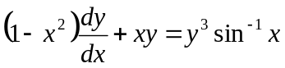. [ 5 ]
b) If the air is maintained at 30⁰c and the temp of the body cools from 80⁰C to 60⁰C in 12 mts, find the temp of the body after 24 mts. [ 5 ]

3. Solve 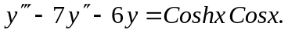

4. a) Find from definition of Laplace transoforms L (sin (at)) and use transform of derivates to find L(Cosat). [ 5 ]
b) Find 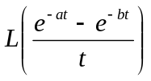 [ 5 ]
5. a) State convolution theorem on Laplace transforms and use it to evaluate
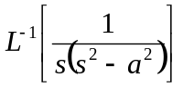. [ 5 ]
- Solve 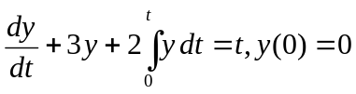 by Laplace transform technique. [ 5 ]

6. a) Show that 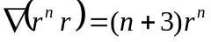, where is the position vector and hence show that 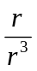 is solenoidal. [ 5 ]
b) Find the directional derivative of 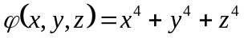at the point (-1,2,3) in the direction towards the point (2,-1,-1). [ 5 ]

7. Expand f(x)=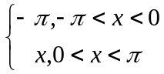 as a Fourier series and hence deduce that 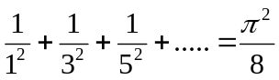.

8. a) Solve x(y-z)p+y(z-x)q=z(x-y), where 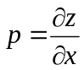 and 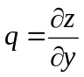.
b) Solve the Laplacian equation 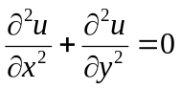by Variable – separable method.

-- 00 -- 00 --

